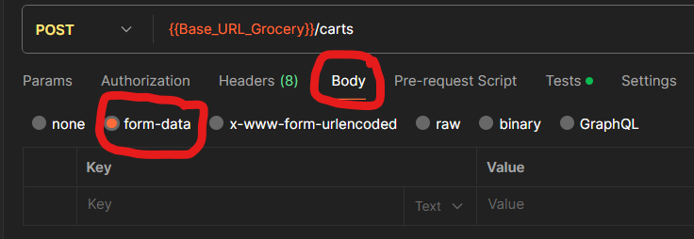

When we execute a **post** or **put** request in a postman, there is a type of body: form-data, it is nothing but key - value pairs that can be sent along with API requests.

So typically the form data option is used when the client wants to send a huge amount of data to the server, for example to send the file. The different name for form-data is multipart form data. This is because the data is sent in parts to the server. With an example of a file it means that the file would not be sent for one request to the server. It will be sent in parts.

Example:

In a request we are sending the text ‘bar1’(with form-data) and in a response we can see the output.

